*Intergalactic warriors*

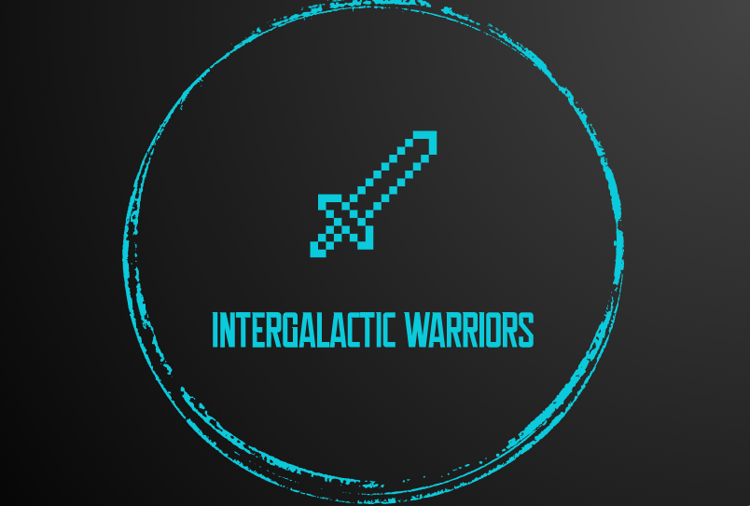

Documentation

Physics project 2021

**Content of the documentation**

**1. Team and members** 2

**2.** **Project** 2

2.1 Idea 2

2.2 Work 2

2.3 Difficulties 3

2.4 Game 3

**3.Used functions** 5

**1. Team and members**

⚫ Ivan Georgiev

* Scrum trainer
* [IKGeorgiev20@codingburgas.bg](mailto:IKGeorgiev20@codingburgas.bg)

⚫ Maksim Vasilev

* Back-end developer
* [MDVasilev20@codingburgas.bg](mailto:MDVasilev20@codingburgas.bg)

⚫ Bozhidar Boyadzhiev

* Back-end developеr
* [BPBoyadzhiev20@codingburgas.bg](mailto:BPBoyadzhiev20@codingburgas.bg)

⚫ Mariyan Ivanov

* QA Engineer
* -
* [MVIvanov20@codingburgas.bg](mailto:MVIvanov20@codingburgas.bg)

**2. Project**

**2.1 Idea**

Our idea for this project was to make a mixture of golf and pong game.

**2.2 Work**

**First part** – discussion and distribution of the roles. After we formed our team, we created a group in Discord, where our conversations took place during the project activity.

We discussed ideas, and distributed the tasks and started working.

**Second part** – creating the game. After assigning the roles and the tasks everybody started working on something and helped each other if we had any difficulties. We discussed a lot of time and edited details on almost every task so we knew we made it successful.

**Third part** – presenting and the final touches. The last part of our work was to commit our finished tasks of our project and present them to our mentor.  
This is the main part of our code:

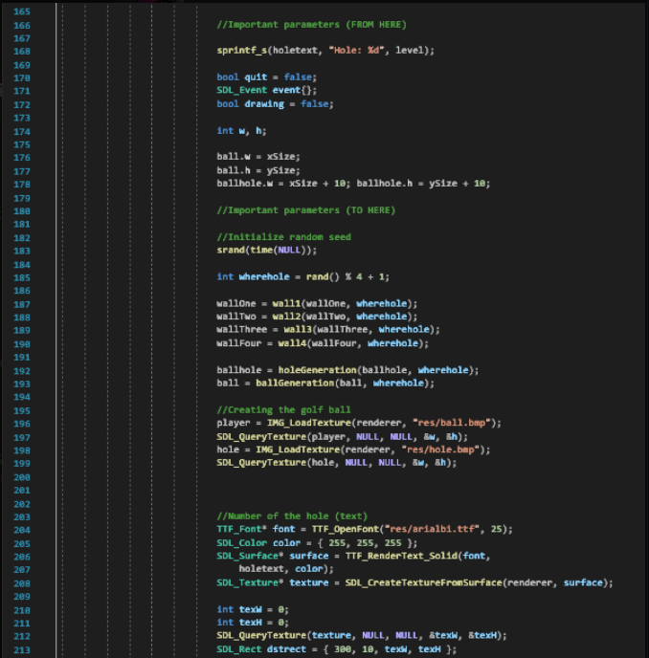

**2.3 Difficulties**

While writing the code, we had issues with memory leaking and movement of the ball, but we worked as a team and we managed to cope it.

**2.4 Game**

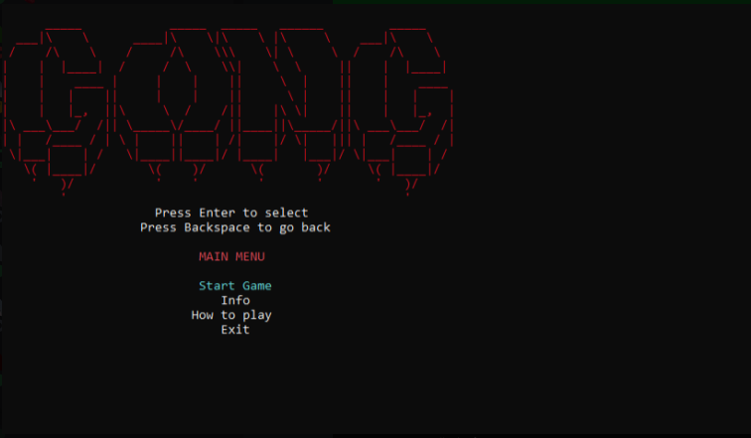

**Our main menu:**

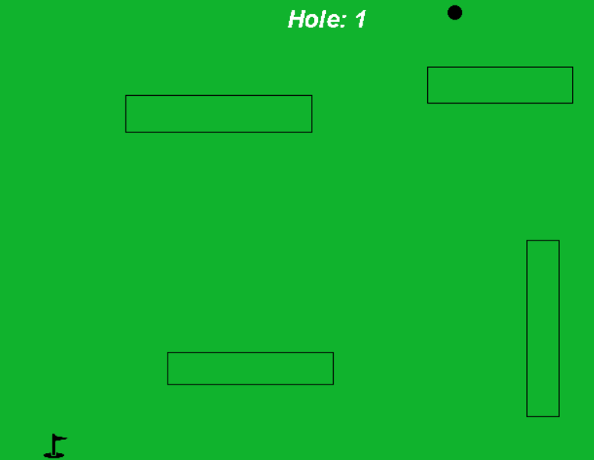

**Our game:**

**2.5 Tables of the used functions**

|  |  |  |
| --- | --- | --- |
| Function name | Function type | What it does? |
| init | bool | Initializes the window |
| loadMedia | bool | Loads the media |
| close | void | Closes the game |
| PointInReact | bool | Checks points in the walls |
| collision | bool | Collision of the window |
| collisionX | bool | Collision of the horizontal sides of the walls |
| collisionY | bool | Collision of the vertical sides of the walls |
| wall1 | structure | Generates randomly the first wall |
| wall2 | structure | Generates randomly the second wall |
| wall3 | structure | Generates randomly the third wall |
| wall4 | structure | Generates randomly the fourth wall |
| ballGeneration | structure | Generates randomly the ball |
| holeGeneration | structure | Generates randomly the hole |
| GetRandomNumber | int | Generates a number randomly for the velocity of the ball |